About The Education Project by Humanity First USA
The Education Project was founded in March 2020 amidst the pandemic with the mission to provide high-quality, remote tutoring and mentorship to K-12 students in need across the nation, completely free of cost. The volunteer tutors are primarily college students, but also include recent grads, teachers, and other professionals.

All tutors are trained to work with students on an individual basis and focus on developing problem-solving skills and improving subject areas where students have difficulty. This one-on-one approach to learning ensures that students are engaged and can gain mastery over fundamental concepts that will be built upon in their future education. Our tutors also act as mentors for students in developing an interest in education and learning itself.

As of December 2020, The Education Project has served over 400 students and provided over 4000 hours of tutoring, with over 225 tutors representing 31 different states. In terms of the internal organization structure, we are a growing team of about 45 volunteers over 6 departments – Tutor Education, Tutor Onboarding, Website, Digital Media, Outreach, and Feedback.

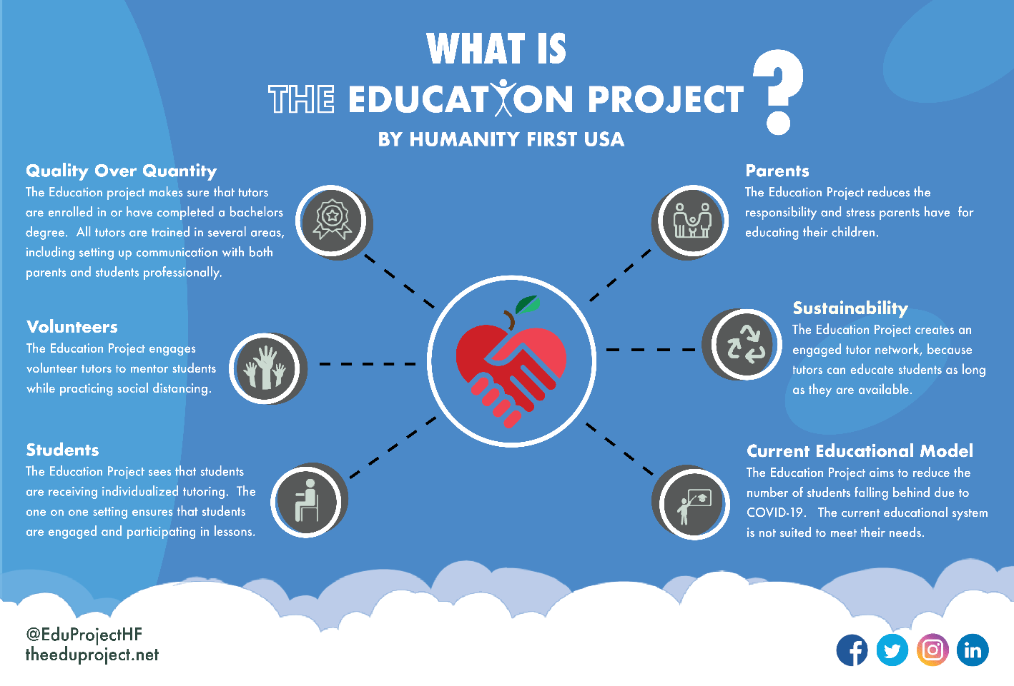
We are an organization under Humanity First USA. Humanity First USA is a registered 501(c)3 non-profit that has served in human development and disaster crises across America and internationally since 2004. For further information on The Education Project, please visit our website: www.theeduproject.net
Potential Internship Placements:

Process & Feedback Department Intern
Our Feedback Team efforts are advised by Dr. Basiyr Rodney, Ed.D.
Our team will work with the intern to discuss interests and potential projects of interest. A few areas the intern will be involved in:
- Data Collection
  - Create infographics, graphs, tables
- Matching students at under-resourced schools
- Grant Search and Grant Writing
- Expedited Admin Work

Outreach Department Intern
Our Outreach Team consists of local ambassadors from CT, TX, CA, OH, PA, FL, MA, and PR.
Our team will work with the intern to discuss interests and potential projects of interest. A few areas the intern will be involved in:
- Coordinating Partnerships
  - Universities, Nonprofits, Corporate
- Public Relations and Press Releases
- Tutor Recruitment
- School Partnerships

Potential week breakdown (8-10 hrs./week)
Our team will work with the intern to set a schedule in the first two weeks of the internship
- 2-3hrs tutoring/mentoring
- 4-5hrs within dept/area of choice
- 1hr weekly roundtable
- 1hr weekly core team strategy meeting (optional)

Work Culture:
- Students
- Young Professionals

Skills and Knowledge Required:
We are looking for online, remote interns interested and knowledgeable in non-profit work. In the spirit of the whole organization, enthusiasm and passion for the vision and mission as well as respect for diverse cultures and backgrounds is essential. The ideal candidates will be service-oriented; have the ability to meet timeframes; possess strong oral and written communication skills; work as a team player; communicate clearly, concisely and professionally with others; have a willingness to learn and be flexible.

